Charlene M. Blondo | MUS 723 | Northern State University

Choral Warmups

Sandra Frey Stegman says it best in the opening sentence of her article, “Choral Warm-ups: Preparation to Sing, Listen, and Learn” found in the Music Educators Journal, “mindless repetition or intentional preparation – the warm-up period can serve either purpose” (2003, p. 37). So why, then, should we not only incorporate warm-ups but carefully and with intent prepare them? The answer is simple: to enhance and improve singing technique, to increase listening and reading skills, and to provide more opportunity for applied learning.
Before we begin exploring a particular warm-up method, I think it is beneficial to discuss the importance of the words we use in warm-ups and in the potential success of the warm-up’s intended function. I have had the privilege of observing Dr. Axel Theimer, professor at University of St. John’s and College of St. Benedict in Minnesota, while he worked with students each year who were part of the National Catholic Youth Choir (NCYC) and have had the opportunity to work with him during various liturgical workshops. He rarely talks about breath control, breath support, posture, vowel formation and placement, resonance, and many of the other terms we are familiar with in choral singing. He stresses the notion that if it does not feel good to sing, then change it so it does. He begins with a natural stance and goes from there. If he feels a singer is not standing with his/her best posture, he encourages that student to stand like what he/she imagines a great singer would stand like. When discussing breath and proper breathing, he uses imagery to help singers find where the breath needs to be and how to use it. He keeps trying different images until he hears a singer(s) singing with better breath support. As he works with singers in producing pure vowels he asks them to first close their eyes and imagine what that sound should sound like and look like and imagine themselves producing that sound. He approaches blend and resonance the same way. Singers are responsible for blend and resonance. If the choir is not blending, he asks the group to fix it rather than a particular section or individual. Dr. Theimer seldom addresses pitch since if singers stand with a natural and relaxed but ready to sing stance, know how to let their breath function, and can imagine and produce the vowels, pitch takes care of itself.
I have witnessed one other director whose approach was very similar to Dr. Axel Theimer. That director is Mrs. Melanie Malinka of the Madeleine Choir School in Salt Lake City, Utah. At this private Catholic choir school, every student takes private lessons with Mrs. Malinka. During lessons as well as during daily choir rehearsals, her focus is on the natural voice. She, like Dr. Theimer, uses imagery to achieve the best individual and natural tone from her students. One example I have that she uses and I have tried with my own students addresses the idea of space inside the mouth. She asks the students to imagine a huge cathedral space inside their mouth. She asks them how they could create that space. Once they are able to create it or describe how to create it, she has them humming followed by singing a variety of vowels in their middle register to get comfortable with that big space. As students describe how to make that space happen, they often refer to using their tummies to blow the space up, standing tall so the space can be bigger, and forming their lips so that the cathedral is warm and cozy.
Bonnie Sneed suggested in her article, “Teaching Good Breath Technique: It Starts in the Warmup”, that warm-ups should begin with breathing exercises (Sneed, 2000). She cautions directors to choose words wisely when teaching breath technique. She prefers using words like breath management as opposed to breath control, since ‘control’ implies tension. Like Dr. Theimer and Mrs. Malinka, Sneed uses imagery to achieve desired goals. Another conductor who begins warm-ups with breathing is Nancy Telfer. During an interview with Telfer, composer, conductor, and clinician, she highly recommended that all rehearsals begin with warm-ups and that the warm-ups begin with breathing exercises (Telfer, Brendell, 1997). As Telfer says, by beginning with breathing, singers are able to transition into singing because focus on breath prepares their minds and their bodies for singing.
Warm-ups can be more than just preparing a voice for singing. I believe that warm-ups are crucial for proper and successful vocal production and singing as well as long term vocal health. Warm-ups also help students to learn singing fundamentals, how to read music, how to sight read music, how to listen, how to sing expressively, and how to sing their regular repertoire they are working on. Through the years, I have used warm-ups that I learned through private instruction and my personal choral experiences. A resource I recently found includes a warm-up process that reflects my ideas of what warm-ups should be. This resource is “The Complete Choral Warm-up Book: A Sourcebook for Choral Directors” by Russell Robinson and Jay Althouse.
This choral warm-up method book is organized well and the contributors offer simple suggestions on how to use the book and the exercises in it. It begins with an explanation of why warm-ups are necessary as well as special warm-up considerations for different age groups and situations. Robinson and Althouse include an informative section regarding vocal rest and how it important it is for vocal health. The first step in choral warm-ups are physical warm-ups. The book gives clear explanations of what the warm-ups are and their intended purpose along with illustrations. The book also includes illustrations of good versus poor posture and vowel formation. See figures 1a-1d.
GOOD POOR
Figure 1a
GOOD POOR
Figure 1b
GOOD POOR
Figure 1c
Figure 1d
Warm-ups are intended to get the choir singing as a group rather than as individuals (Robinson & Althouse, 1995). Once the singers’ bodies are limber, muscles relaxed, and focus is on breath, warm-ups move into simple exercises that allow for feelings of resonance. The method book provides several exercises and descriptions of how each should be executed along with what their specific function is. In addition, Robinson and Althouse provide suggestions in how to alter the exercises to meet specific needs and goals. Transitional warm-ups follow the beginning warm-ups and have a more specific purpose. The purpose may be vocal flexibility, vocal range, rhythms, continued work on breath support, or phrasing. Next are ‘fun’ warm-ups. Not all fun warm-ups have a real purpose to singing other than being fun. It is important to utilize fun warm-ups with specific purposes in mind. Functions of fun warm-ups include work on consonants and to increase flexibility through emphasis on the lips, tongue, and muscles of jaw and throat. See figures 2a-2c for examples from “The Complete Choral Warm-up Book”.
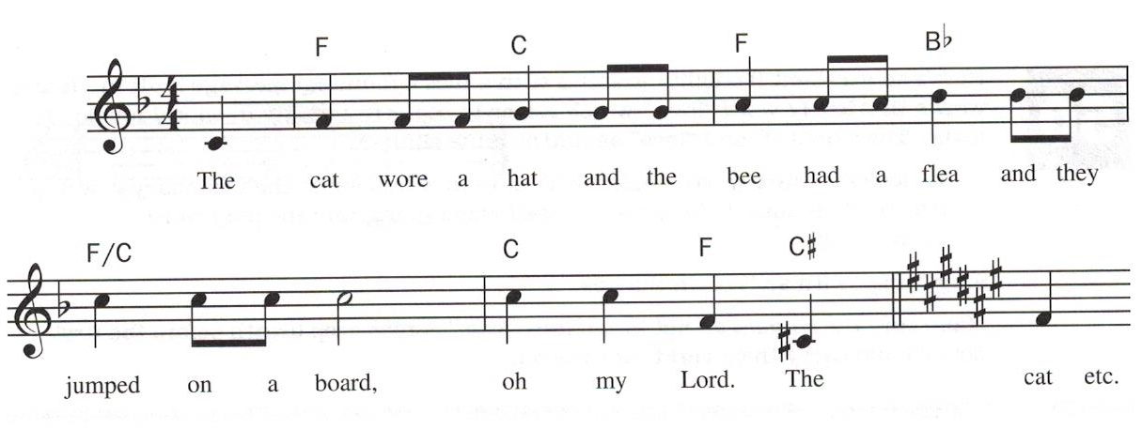
Figure 2a
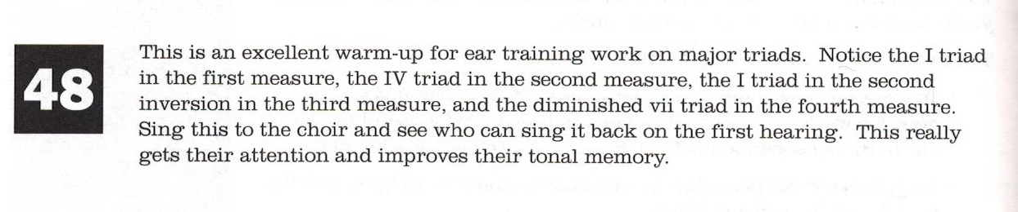
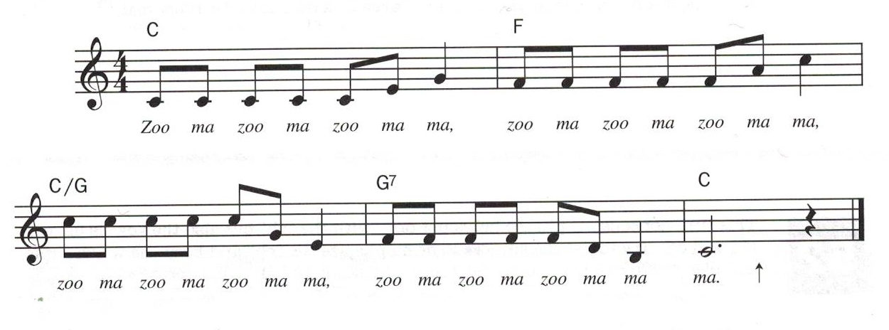
Figure 2b
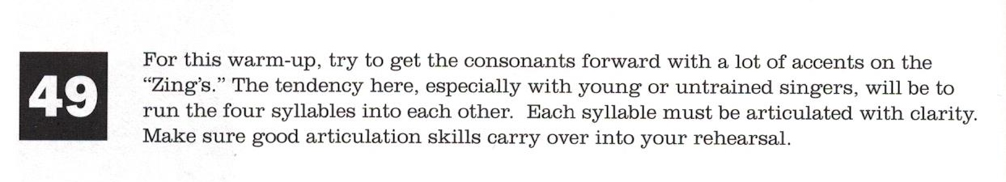
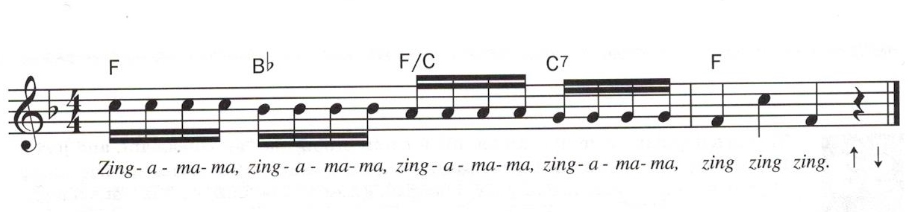
Figure 2c
Following transitional warm-ups are specific exercises such as chordal warm-ups (2 part, 3 part mixed, SSA, SATB), interval training, style specific warm-ups, and rounds. It is important to remember that warm-ups do not always have to take place at the beginning of the rehearsal. Since warm-up exercises work on overall proper singing technique, in particular the specific exercises listed above, they may take place any time during the rehearsal to reinforce what is being rehearsed (Robinson & Althouse, 1995). It is important to note, too, that any warm-ups can be changed to fit particular needs of the ensemble or the repertoire being studied.
Part of the warm-up process or method should include sight reading skills. Steven Demorest talks about the importance of sight reading during warm-ups and rehearsals in his article, “Integrating Sight-Singing into the High School Choral Rehearsal” (1998). When done well, Demorest says that sight singing exercises will improve the musicianship of the ensemble. He suggests that sight singing exercises should be integrated throughout each and every rehearsal rather than be limited as part of a warm-up only, not having a connection being made to the music and how the skills being learned are applicable. “The Complete Choral Warm-Up Book” does not include any specific exercises for sight singing. I have found many sight reading resources available. The one I choose to incorporate into my warm-up method is “Successful Sight Singing: A Creative, Step by Step Approach” by Nancy Telfer.
In “Successful Sight Singing: A Creative, Step by Step Approach”, Telfer includes an easy to follow and scaffolding approach to sight singing. This method covers all levels of difficulty, is designed for unison to 3-part singing, introduces rhythms and interval sequentially, incorporates key signatures, changes in time signatures, and uses Solfege with a ‘La’ based minor to learn vocal parts. Every element is clearly explained and diagrammed in the student books. The teacher’s edition is even more detailed in how to teach the method.
When approaching warm-ups, it is important to realize they are an integral part in the growth of singers and choirs. They help singers reach their fullest potential as musicians. Planning warm-ups with intent and purpose is imperative for warm-ups to function to their full capacity. Warm-ups can enhance and improve singing technique, to increase listening and reading skills, and to provide more opportunity for applied learning.

References
Demorest, S. (1998). Integrating Sight-Singing into the High School Choral Rehearsal.
The Choral Journal, 39(5), 55-58. Retrieved from http://www.jstor.org/stable/23552681.
Robinson, R. & Althouse, J. (1995). The Complete Choral Warm-Up Book: A Sourcebook for Choral Directors. Alfred Publishing Co.
Sneed, B. (2000). On The Voice: Teaching Good Breath Technique: It Starts in the
Warmup. The Choral Journal, 40(9), 51-55. Retrieved from http://www.jstor.org/stable/23553434
Stegman, S. (2003). Choral Warm-ups: Preparation to Sing, Listen, and Learn. Music
Educators Journal, 89(3), 37-58. Retrieved from http://www.jstor.org/stable/3399856
Telfer, N. (1993). Successful Sight Singing: A Creative, Step by Step Approach. Neil A
Kjos Music Company. San Diego, CA.
Telfer, N., & Brendell, J. (1997). Vocal Development in the Choral Rehearsal: An
Interview with Nancy Telfer. The Choral Journal, 38(2), 27-31. Retrieved from http://www.jstor.org/stable/23551564

